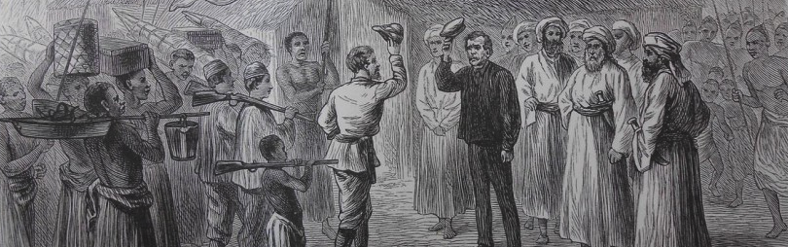

Dr David Livingstone and Henry M. Stanley: Two Lives, One Experience.
BELvue Museum, Sept. 16, 2013
Royal Museum for Central Africa & King Baudouin Foundation, organizers

Seminar held in connection with the exhibition “Dr Livingstone, I Presume”

Info: mathilde.leduc@africamuseum.be

Program
9.30am: registration & coffee
10am: Welcoming address, by G. Gryseels, Royal Museum for Central Africa
10.15am: Welcoming address by An Lavens, BELvue Museum

10.30 – 12.30: Morning panel
Livingstone and Stanley meeting, a historical appraisal
- J. Mokhiber, Associate Professor, University of New Orleans
- J. L. Newman, Professor Emeritus, New York University of Syracuse
- M. Leduc-Grimaldi, The H. M. Stanley Archives, Royal Museum for Central Africa

12.30 – 2pm: lunch break

2pm-5pm: Afternoon panel
Stanley & Livingstone’s trip, a legacy
- F. Driver, Professor, University College of London, Holloway College
- J. Livingstone, researcher, Edinburg University
- Discussant: F. Herbert, Emeritus, Royal Geographical Society (tbc)

5pm: Conclusion & opening by D. Allard, King Baudouin Foundation

5.30-6pm: guided tour, “Dr Livingstone I presume”

